Alg 1 Night School Name: ____________________________

____________ ____________
WS Assessment

Target 6:
MODELING SYSTEM OF EQUATIONS

I can :
- Model systems in multiple ways.
- Make connections between representations (slope, intercepts…)

Standard: A3. Systems
● A3a. I can model systems in multiple ways.
● A3b. I can solve systems using algebra.

Intro to System
The Iditarod Trail Sled Dog Race is famous for its incredible length and its use of dogs. In 2003, the sled drivers, known as mushers, started their dog sleds at Fairbanks, Alaska and rode through the snow for many days until they reached Nome, Alaska. Along the route there were stations where the competitors checked in, so data was kept on the progress of each team. Joyla and her team of dogs made it through the first five checkpoints. At the same time, her buddy Evie left Nome (the finish line) on the day the race started in an effort to meet Joyla and offer encouragement. Evie traveled along the route toward the racers on her snowmobile. The progress of each person is shown on the graph
After analyzing the graph, answer the following
Which data represents Evie? ____ Which represents Joyla? ___ Why? _______________
How far was the race? __________ How long was the race for Joyla? ______ Evie? _________
Who traveled faster? ___________
When, where did Evie meet Joyla? _____________________
Write the meeting point (intersection) in (x, y) format

2. Graph the following on the same set of axes, locate the intersection in (x,y) form then how me on the calculator for stamp

y1 = 3x – 2 and y2 = −2x + 6 y1 = −3x – 2 and y2 = 2x + 6
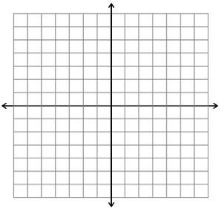

3. Examine each of the graphs below and write a brief story that describes the information in the graph. Include a sentence explaining what the point of intersection represents.

Graph a: _______________________

Graph b: _______________________

Graph c: _______________________

Graph d: _______________________

4. Given the table, write the equation for each, graph them and find the intersection

5. It’s the end of the semester, and the clubs at school are recording their profits. The Science Club started out with $20 and has increased its balance by an average of $10 per week. The Math Club saved $5 per week and started out with $50 at the beginning of the semester.

a. Create an equation for each club. Let x represent the number of weeks and y represent the balance of the club’s account.
Science: y = __________________________

Matj: y = __________________________

b. Graph both lines on one set of axes. When do the clubs have the same balance? Show Algebra and locate it on graph

6. Barbara has a bunny that weighs 5 pounds and gains 3 pounds per year. Her cat weighs 19 pounds
and gains 1 pound per year. When will the bunny and the cat weigh the same amount? Use table, equations and graph to find the solution.
Table | Equation | Graph
 | Bunny  y =  Cat  y =
  Year | Bunny | Cat
  Start | 5 | 19
  1
  2

Multiple Representations
Table – Graph – Equation – Situation and solutions
1. Create another three representations for each case below then decide which town whose population grow fastest.
Table | Graph | Equation | Situation

Which town grows fastest? _____________________________ Why? _____________

2. Given the graph and table below. Locate the intersection and give its meaning with the story of case A and case B

3. Kathy is thinking of a number. When she triples her number, adds eighteen, and then subtracts her original number from the sum, she gets four. What is Kathy’s original number? Show work

4. When Ellen started with Regina’s favorite number and tripled it, the result was twelve more than twice the favorite number. Find Regina’s favorite number. Show work

5. Guess and Check

The length of a rectangle is five centimeters more than twice its width. The perimeter is 100 centimeters.
  L.
  W
  P

Write your answer in sentence ________________________________________________________

For the school play, the advance tickets cost $3 and tickets at the door cost $5. Thirty more tickets were sold at door than in advance, and $2630 was collected.  How many tickets were sold at the door?
  Adv
  Door
  Total

Write your answer in sentence ________________________________________________________

The number of students attending the Fall  play was 150 fewer than three times the  number of adults. Together, students and  adults purchased 1778 tickets. How many  students attended the Fall play?
  Adult
  Stu.
  Total

Write your answer in sentence ________________________________________________________

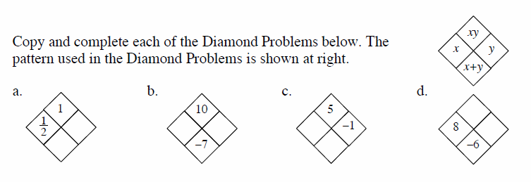
6.

Assessment Target 6 Name:_______________________ Date: __________
I can… Model systems in multiple ways and make connections between representations.

1. Create a representation for the situation below

Figure 0 Figure 4

Table | Graph | Equation (in three forms)
Slope-Intercept y =

Point-Slope y =

Standard

How many tiles Figure 100 will have? _________

2. Create a representation for the situation below
Situation (Story) | Table | Graph | Equation
Priscilla and Ursula went fishing. Priscilla brought a full box of 32 worms and used one worm every minute. Ursula brought a box with five worms and decided to dig for more before she began fishing. Ursula dug up two worms per minute. When did  Priscilla and Ursula have the same number of worms?
  Minute | P | U
  0 | 32 | 5
  3
  6
  9
  12

3. To rent a jet ski at Sam’s costs $25 plus $3 per hour. At Claire’s, it costs $5 plus $8 per hour. At how many hours will the rental cost at both shops be equal? Show work with your choice of method. (Table, Graph, or Equation) If do all three = extra credit.

